Students Handout

Introduction to Web API Workshop 3

This workshop aims to introduce you to the fundamentals of building a Web API using the Repository Pattern and integrating AutoMapper for mapping between DTOs (Data Transfer Objects) and Model entities. The workshop will cover the implementation of two controllers: UserController and JobController.

**Prerequisites**

Before starting this workshop, ensure that you have a basic understanding of C# programming, ASP.NET Core, and Web API concepts.

**Workshop Content**

1. User Controller

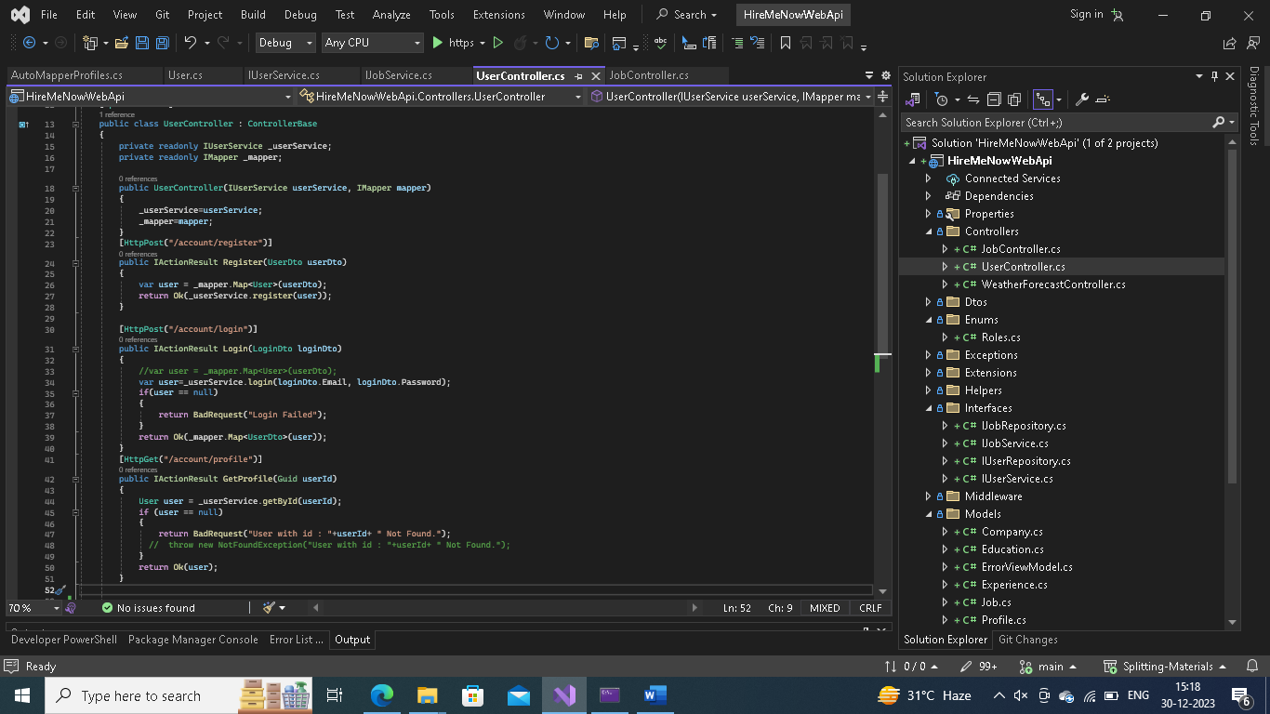

1.1. Controller Overview

Controller Name: UserController

Base Route: /api/UserController

1.2. Dependencies

IUserService: Interface for user-related operations.

IMapper: AutoMapper for mapping between DTOs and Model entities.

1.3. Endpoints

1.3.1. Register User

HTTP Method: POST

Route: /account/register

Action Method: Register(UserDto userDto)

Description: Registers a new user using DTO and AutoMapper.

1.3.2. User Login

HTTP Method: POST

Route: /account/login

Action Method: Login(LoginDto loginDto)

Description: Logs in a user and returns user information if successful.

1.3.3. Get User Profile

HTTP Method: GET

Route: /account/profile

Action Method: GetProfile(Guid userId)

Description: Retrieves the user profile based on the provided user ID.

2. JobController

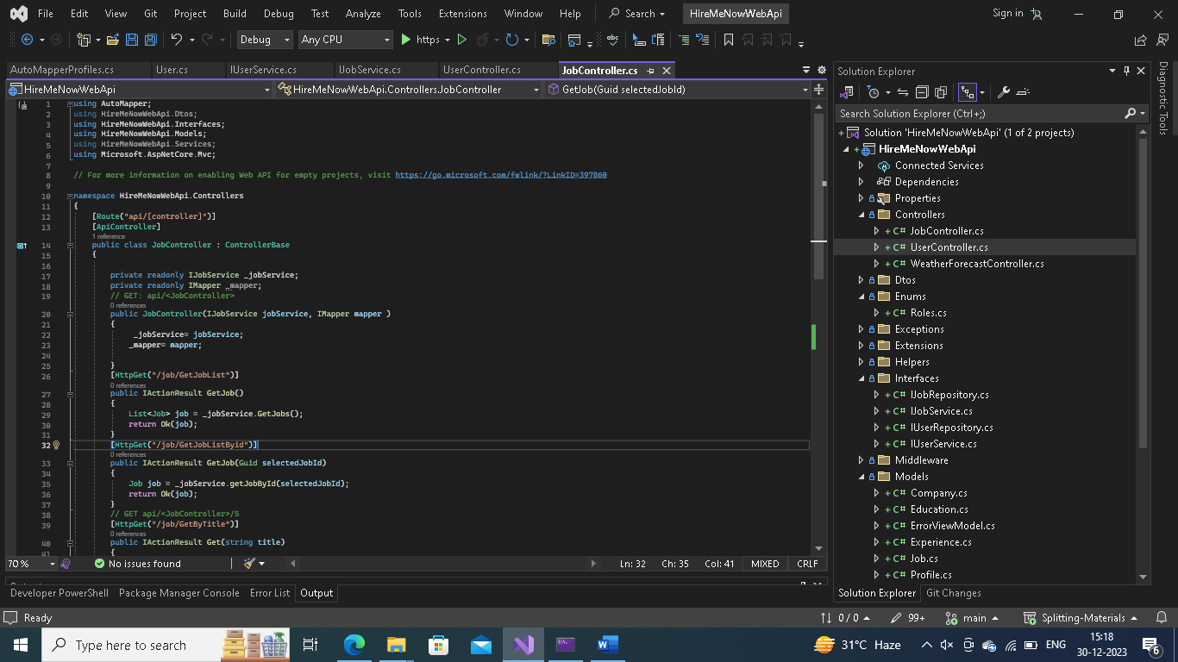

2.1. Controller Overview

Controller Name: JobController

Base Route: /api/JobController

2.2. Dependencies

IJobService: Interface for job-related operations.

IMapper: AutoMapper for mapping between DTOs and Model entities.

2.3. Endpoints

2.3.1. Get Job List

HTTP Method: GET

Route: /job/GetJobList

Action Method: GetJob()

Description: Retrieves a list of all jobs.

2.3.2. Get Job by ID

HTTP Method: GET

Route: /job/GetJobListByid

Action Method: GetJob(Guid selectedJobId)

Description: Retrieves a specific job by ID.

2.3.3. Get Jobs by Title

HTTP Method: GET

Route: /job/GetByTitle

Action Method: Get(string title)

Description: Retrieves jobs based on the provided title.

Conclusion

This workshop provides hands-on experience with building Web API controllers, using the Repository Pattern, and integrating AutoMapper for seamless mapping between DTOs and Model entities. Make sure to follow along with the code samples provided and ask questions to enhance your understanding. Happy coding!